The images below are from publicly available sources on the internet. The researcher explicitly chose these emails as examples of phishing emails with fake image attachments to create a simulated dataset.

**Simulated Test-1:** Fake Invoice Image-1

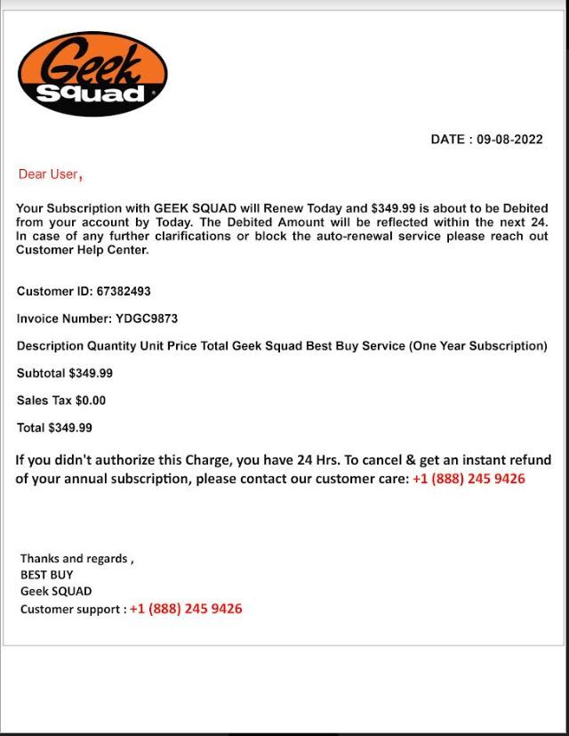

**Simulated Test-1 results:** The script extracted text from Fake Invoice Image-1 and removed the phishing email.

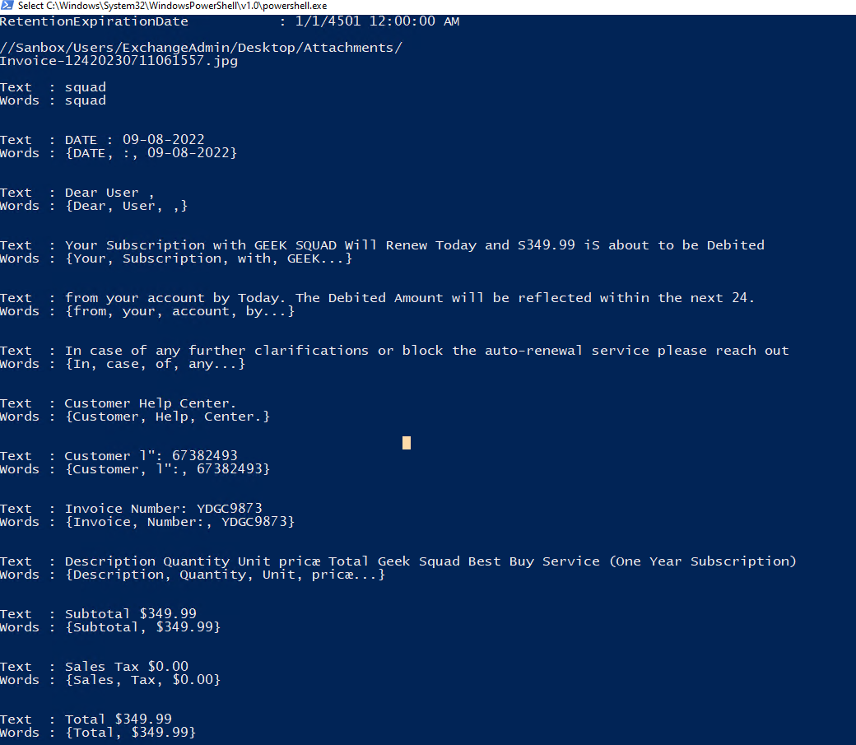

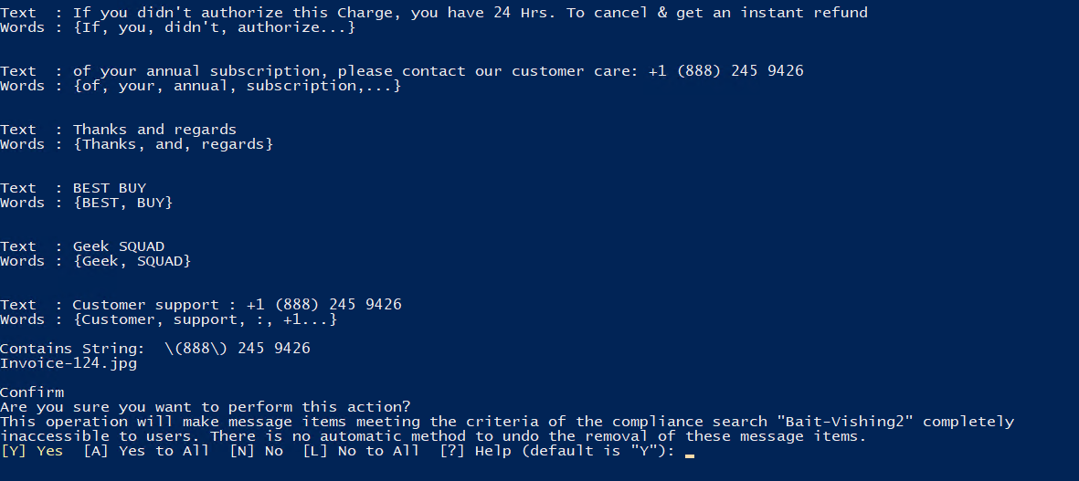

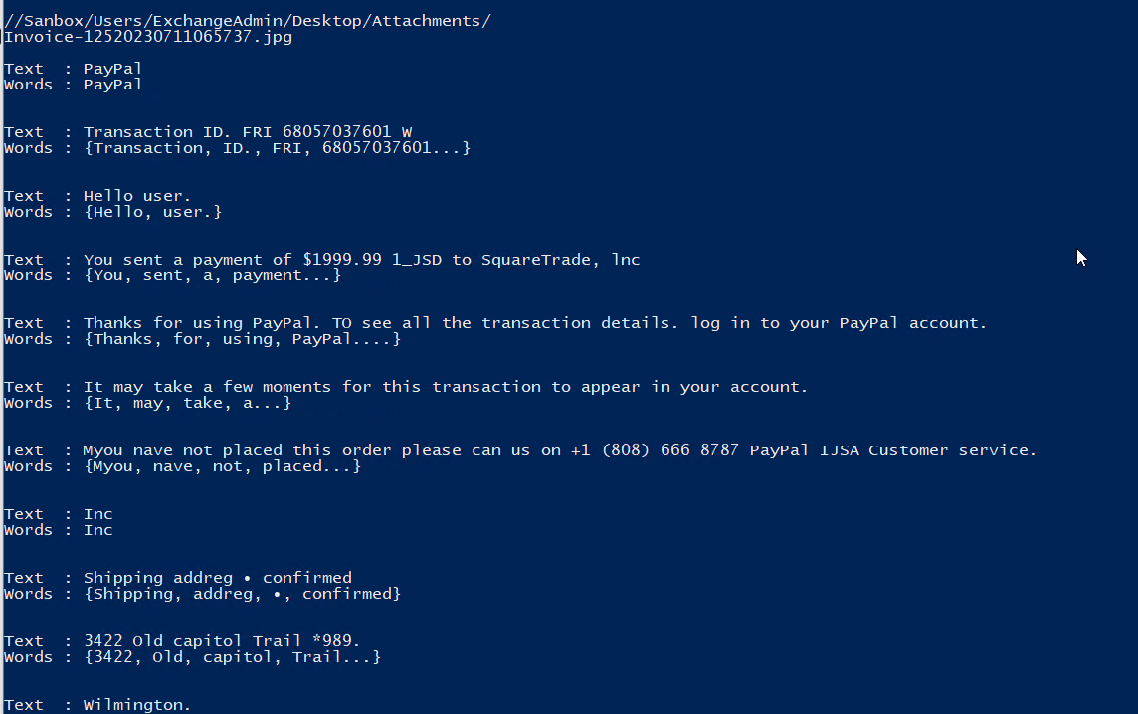

**Simulated Test-2:** Fake Invoice Image-2

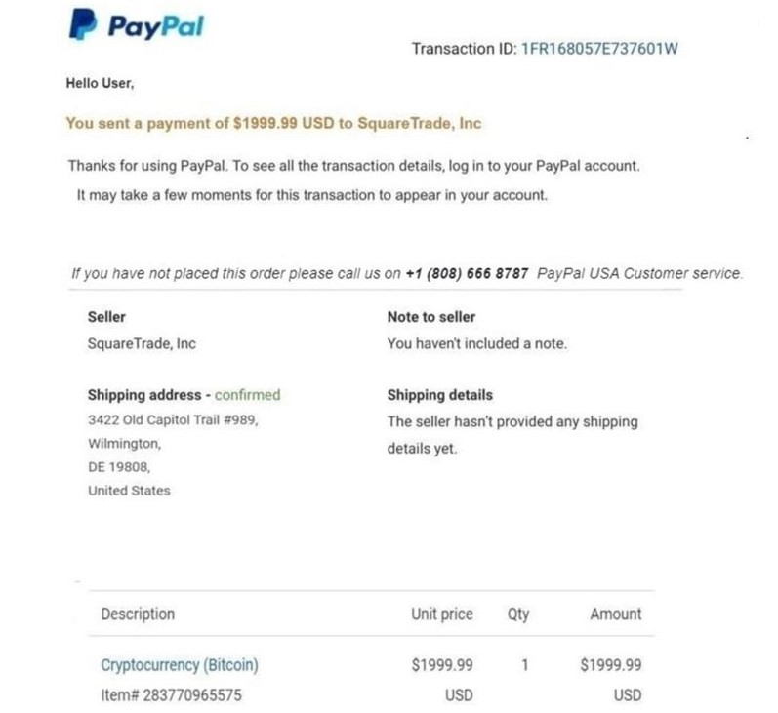

**Simulated Test-2 results:** The script extracted text from Fake Invoice Image-2 and removed the phishing email.



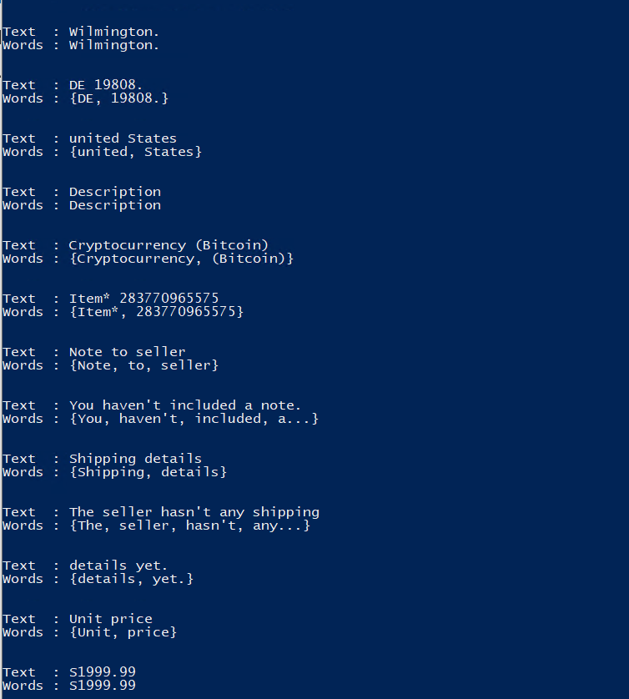

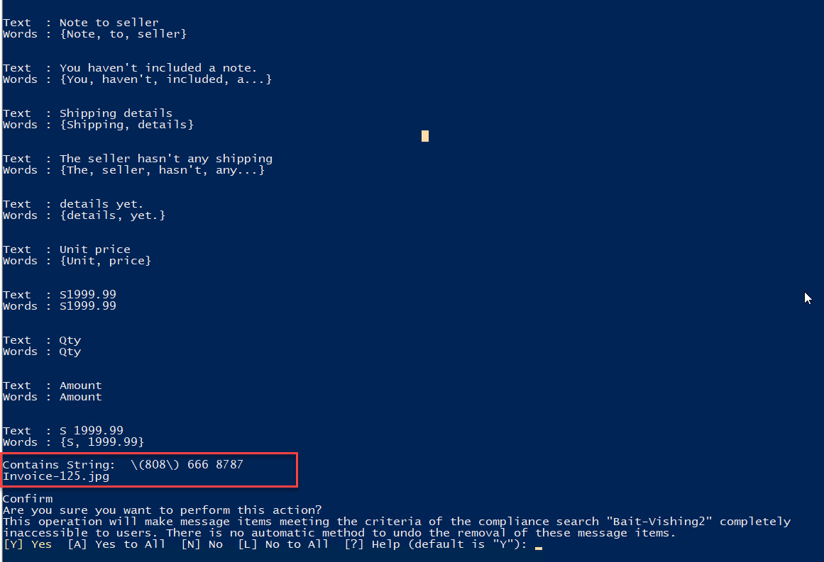

**Simulated Test-3:** Fake Invoice Image-3

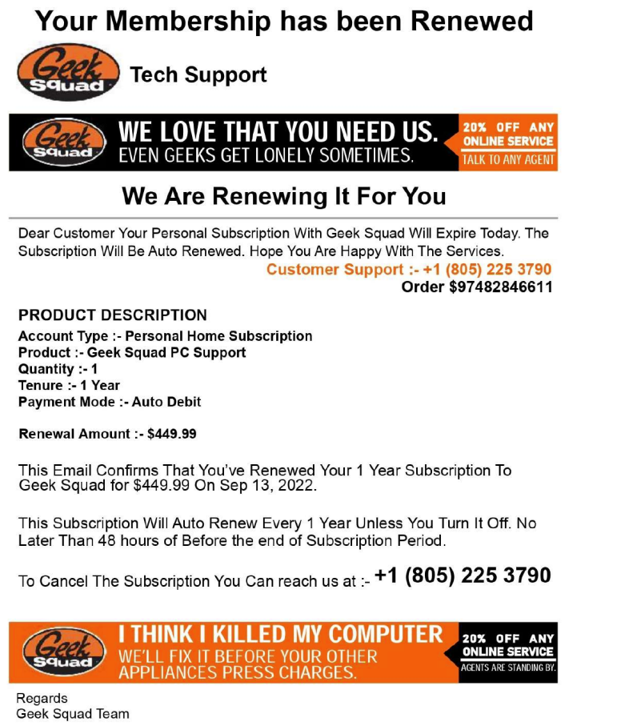

**Simulated Test-3 results:** The script extracted text from Fake Invoice Image-3 and removed the phishing email.

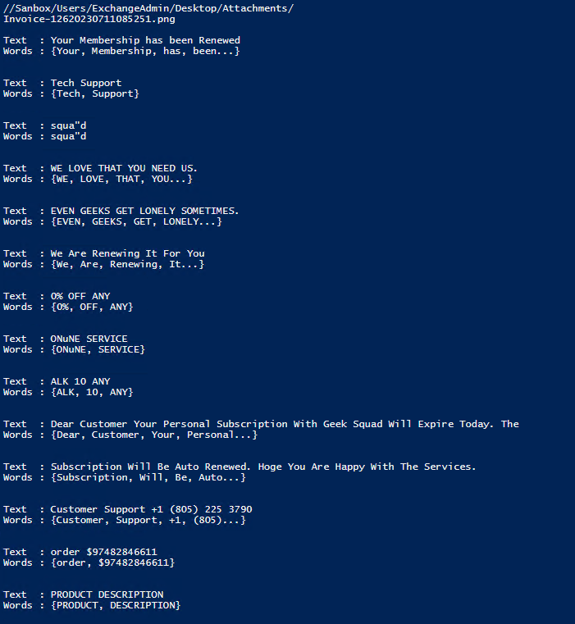

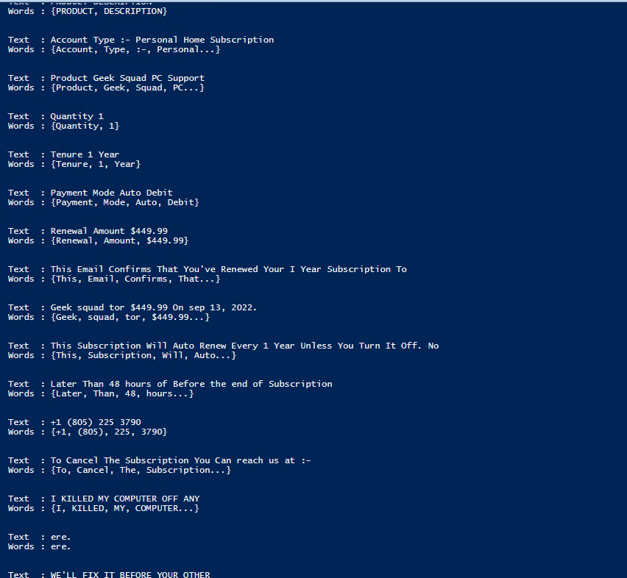

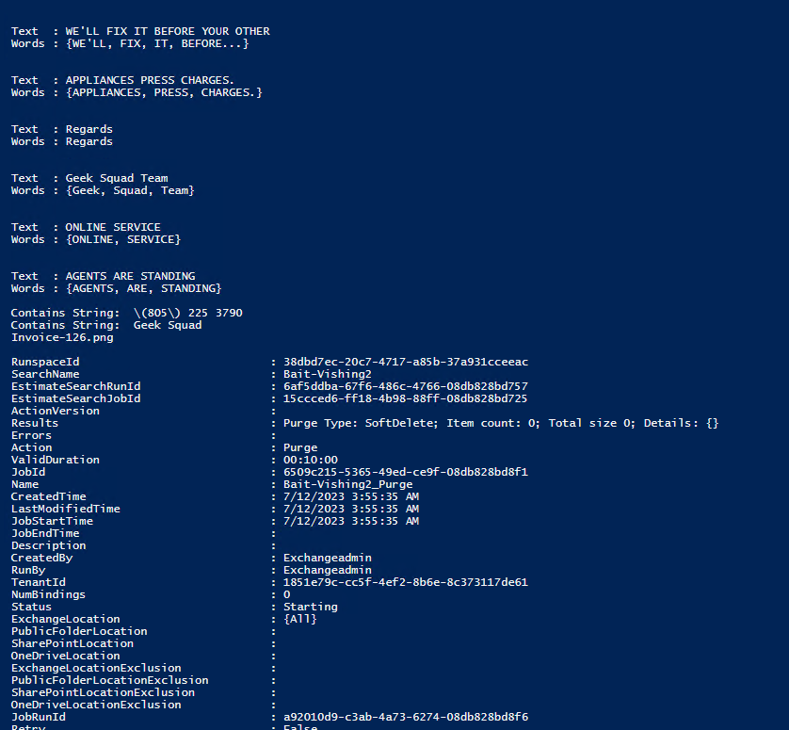

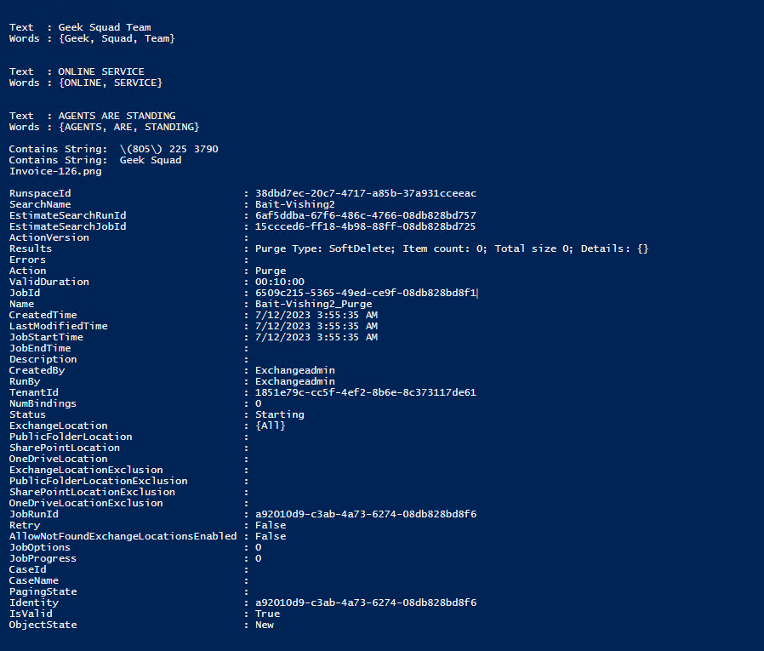

**Simulated Test-4:** Fake Invoice Image-4

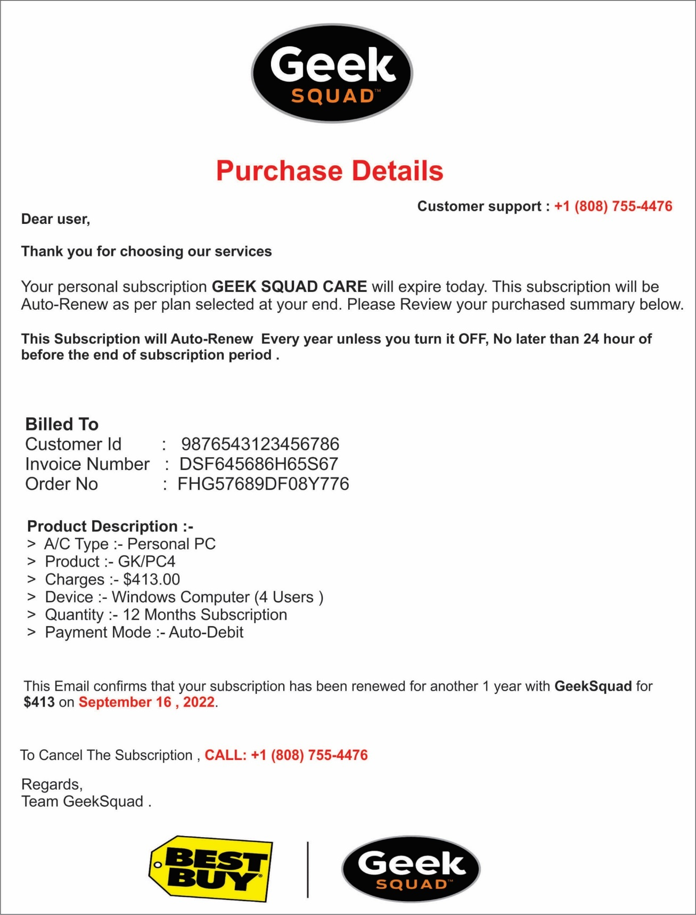

**Simulated Test-4 results:** The script extracted text from Fake Invoice Image-4 and removed the phishing email.

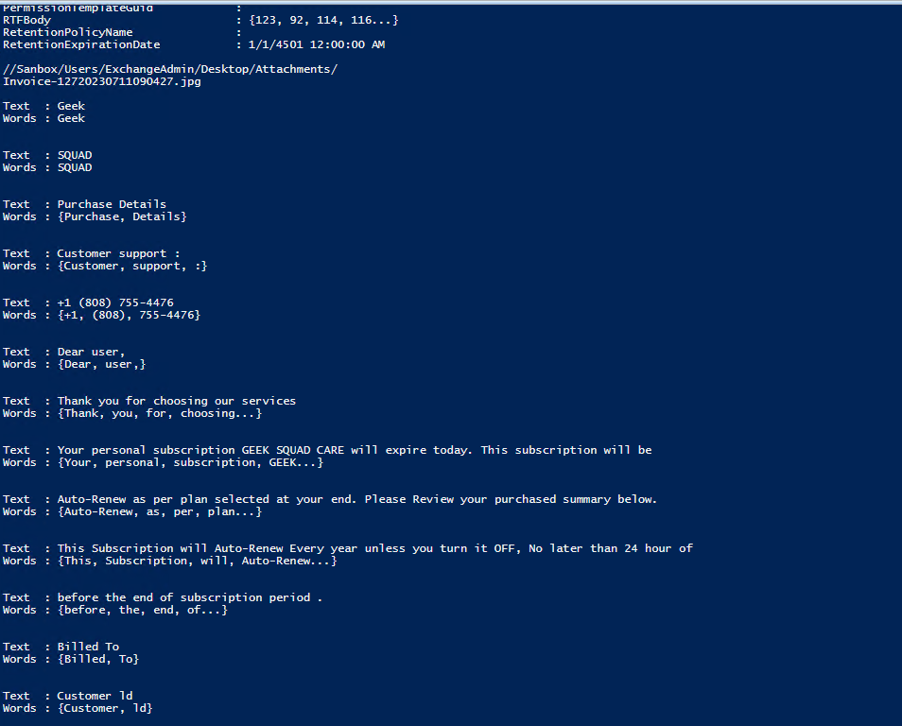

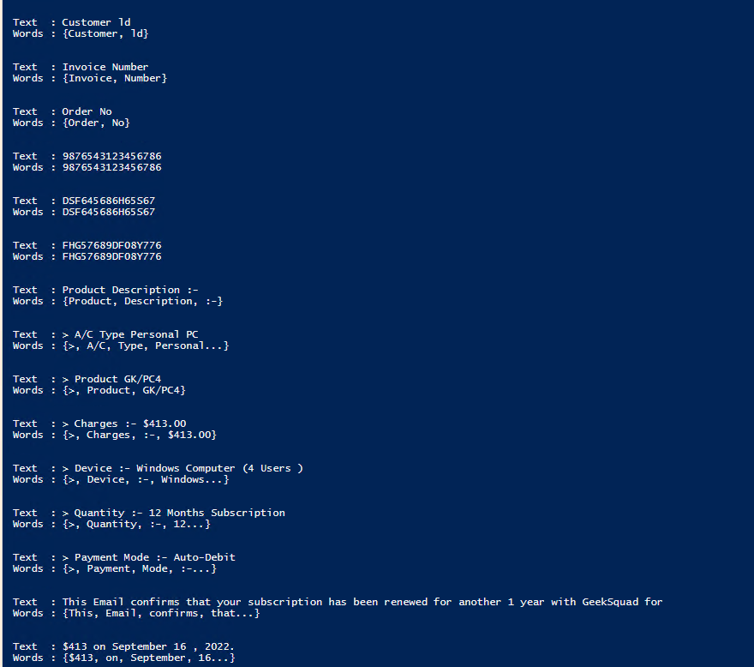

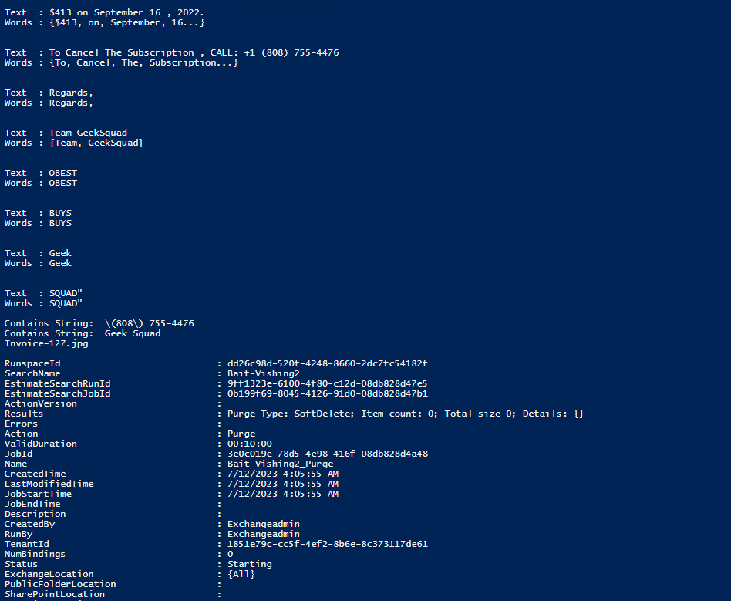

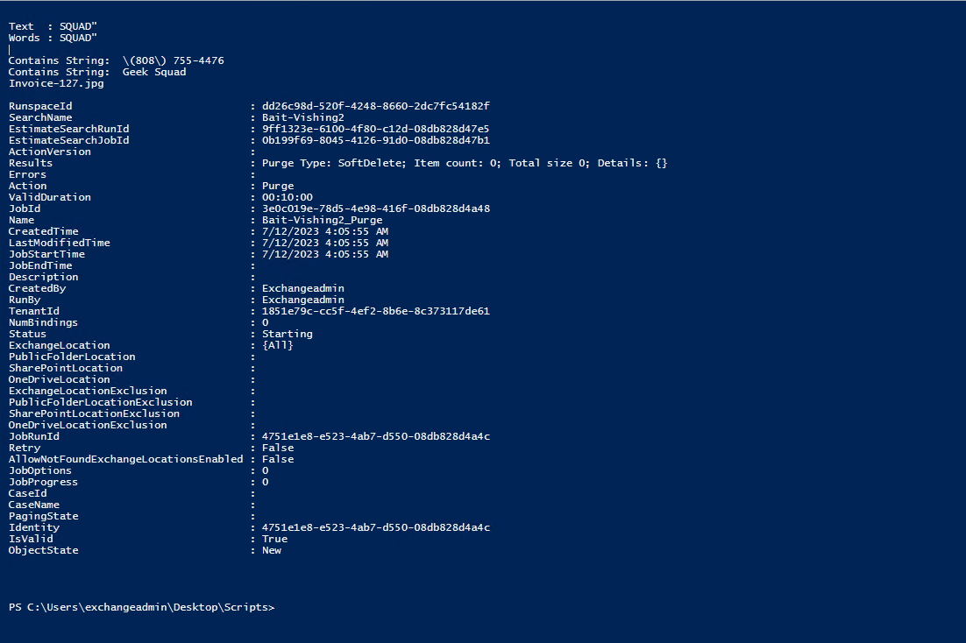

**Simulated Test-5:** Fake Invoice Image-5

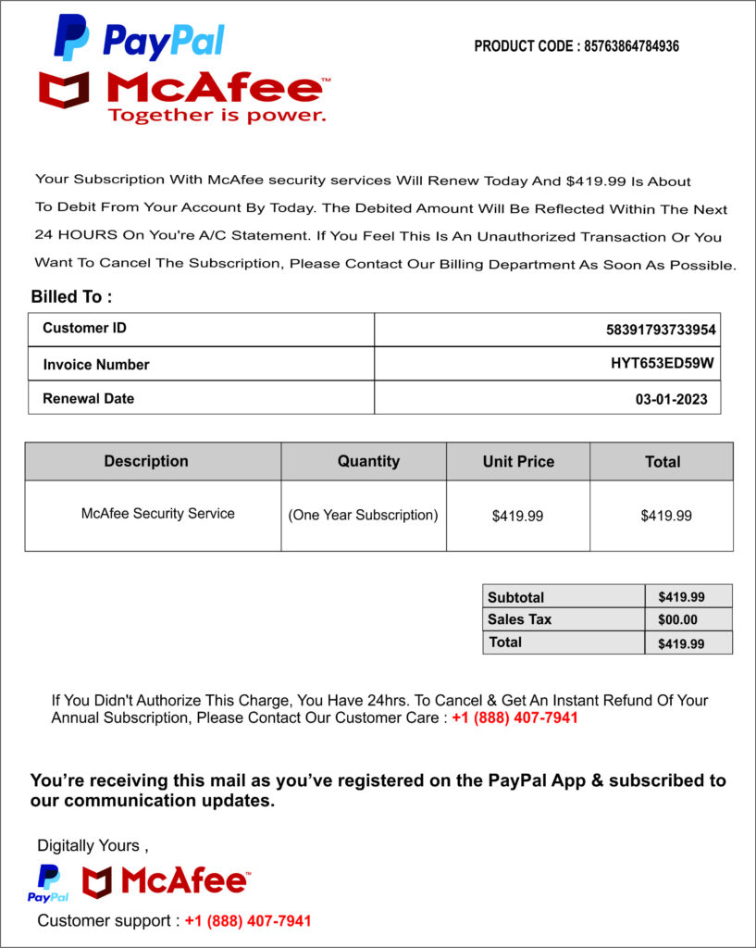

**Simulated Test-5 results:** The script extracted text from Fake Invoice Image-5 and removed the phishing email.

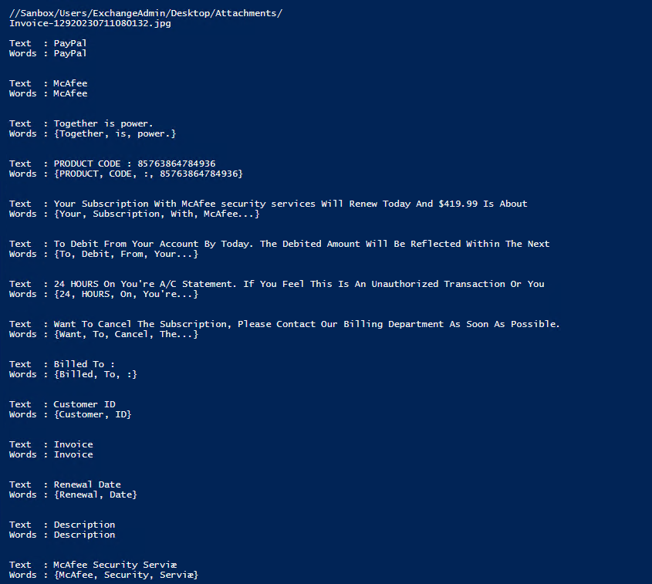

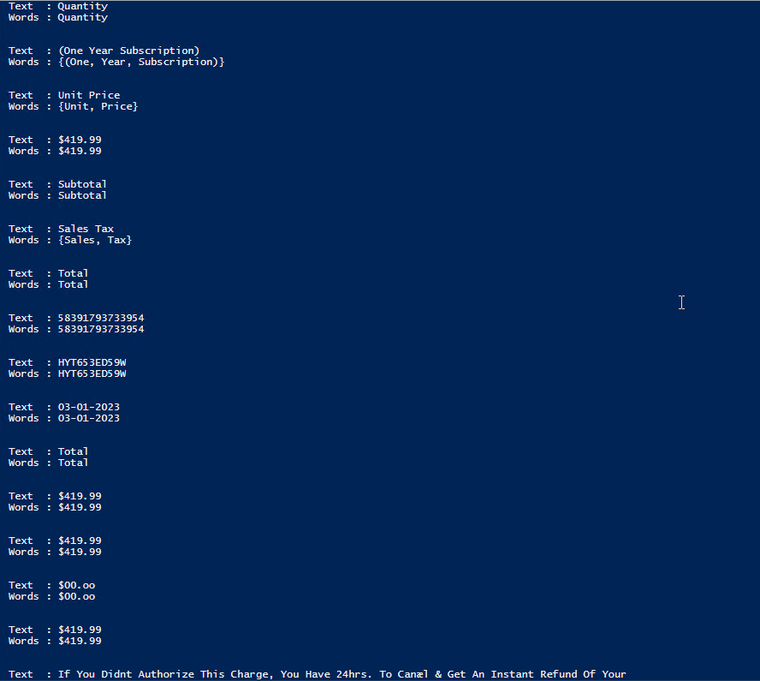

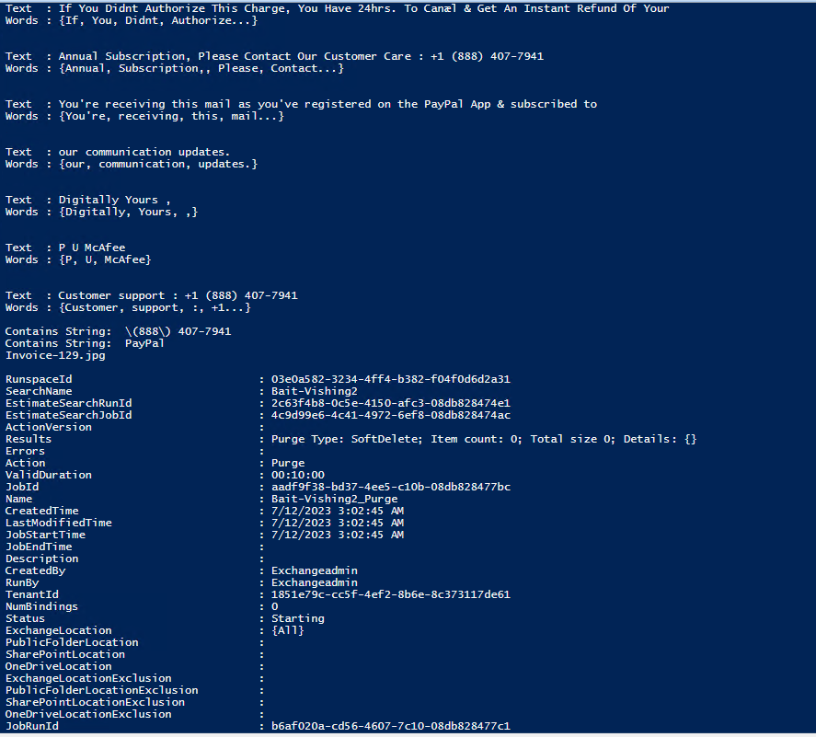

**Simulated Test-6:** Fake Invoice Image-6

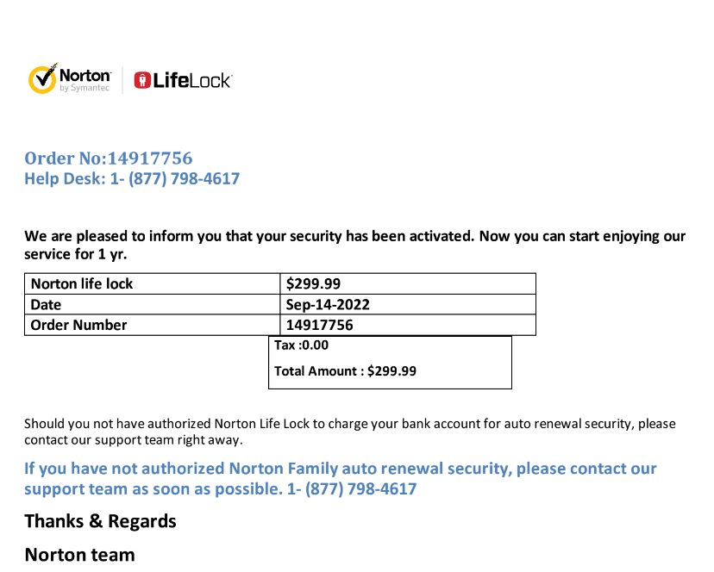

**Simulated Test-6 results:** The script extracted text from Fake Invoice Image-6 and removed the phishing email.

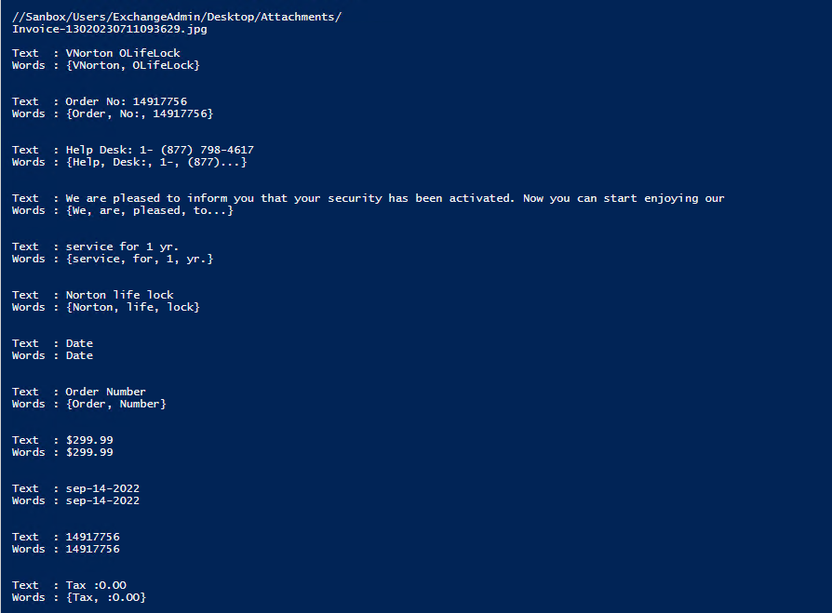

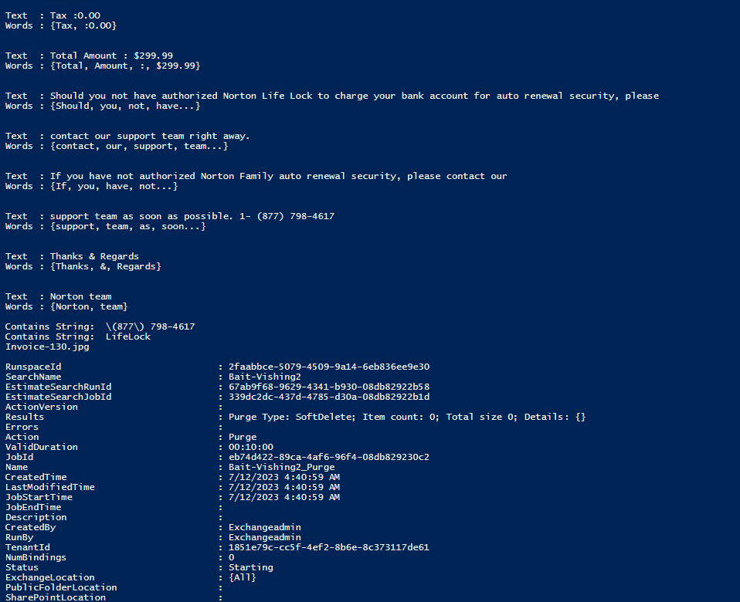

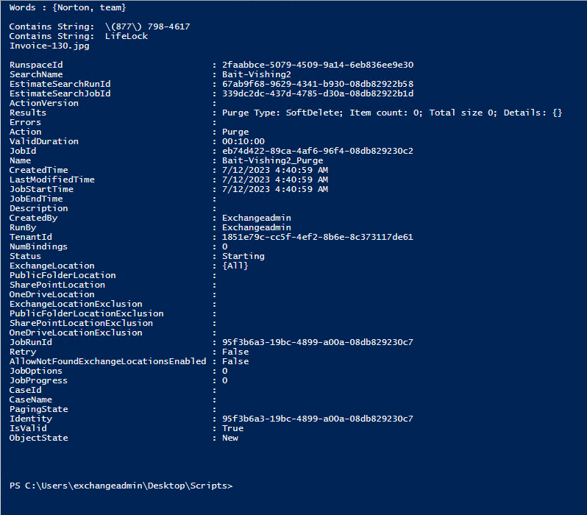

**Simulated Test-7:** Fake Invoice Image-7

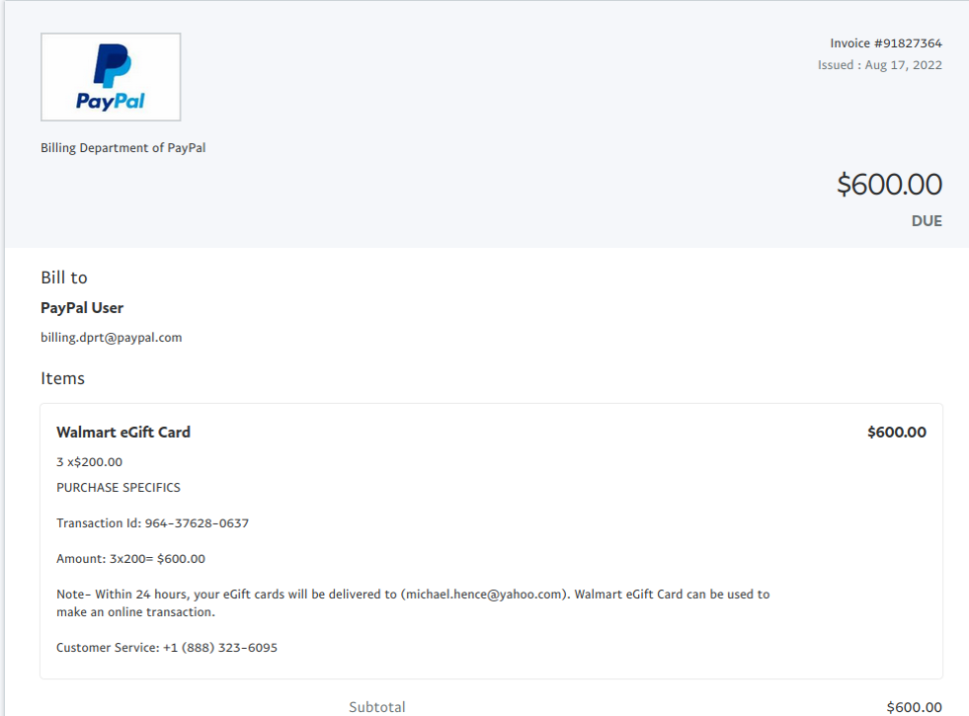

**Simulated Test-7 results:** The script extracted text from Fake Invoice Image-7 and removed the phishing email.

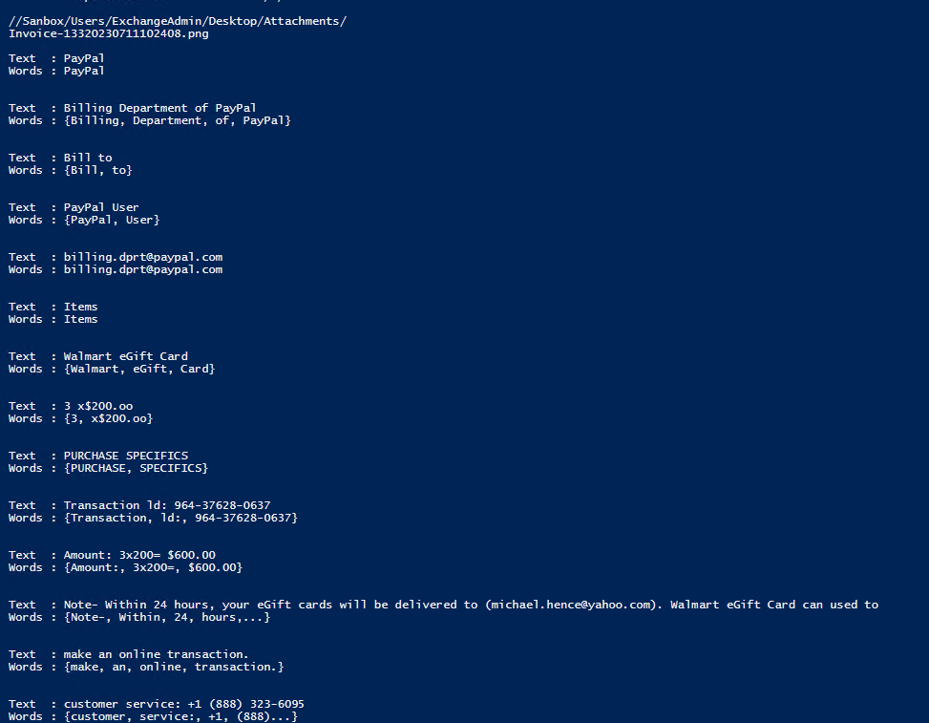

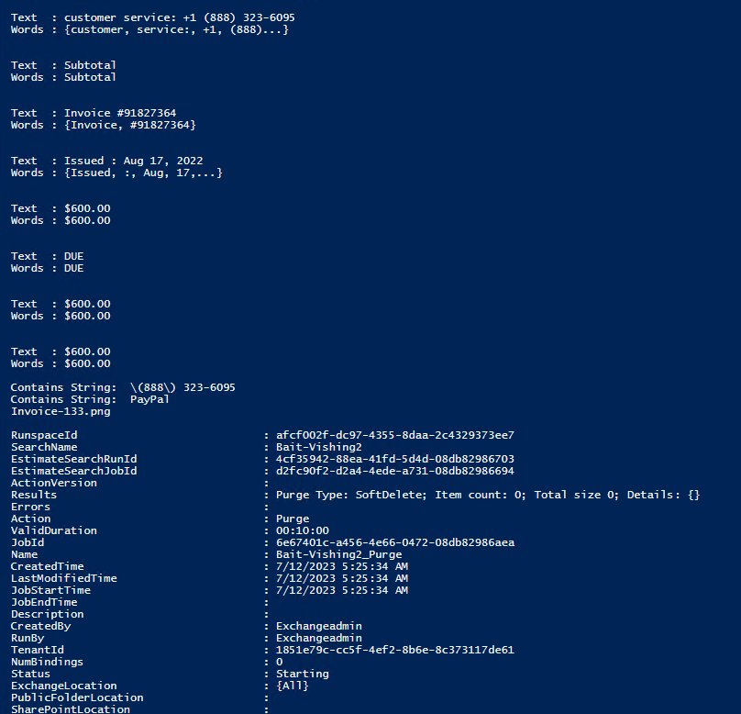

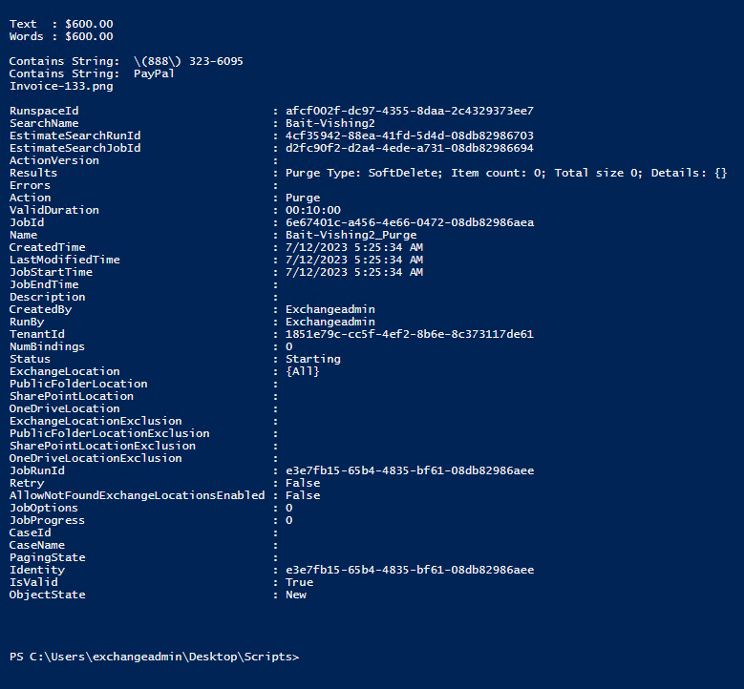

**Simulated Test-8:** Fake Invoice Image-8

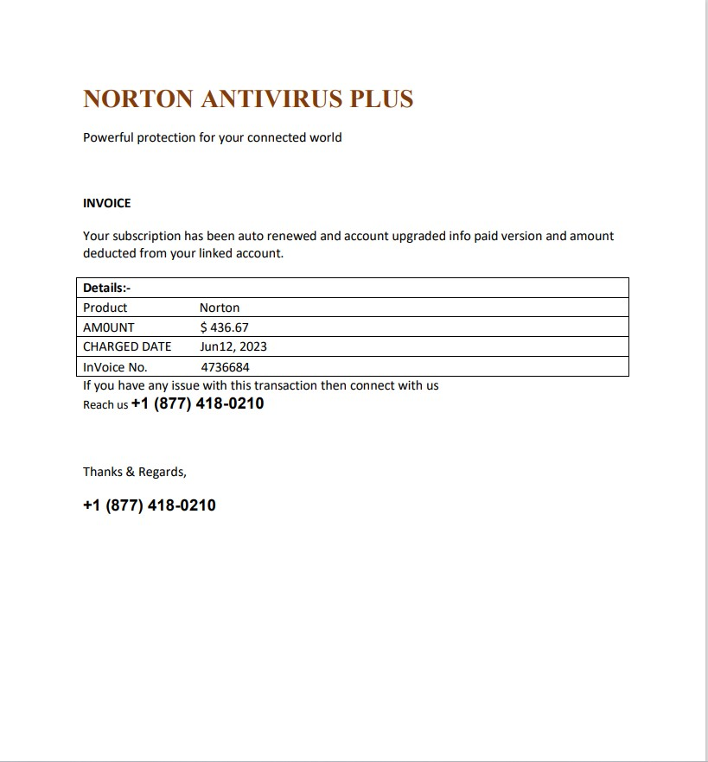

**Simulated Test-8 results:** The script extracted text from Fake Invoice Image-8 and removed the phishing email.

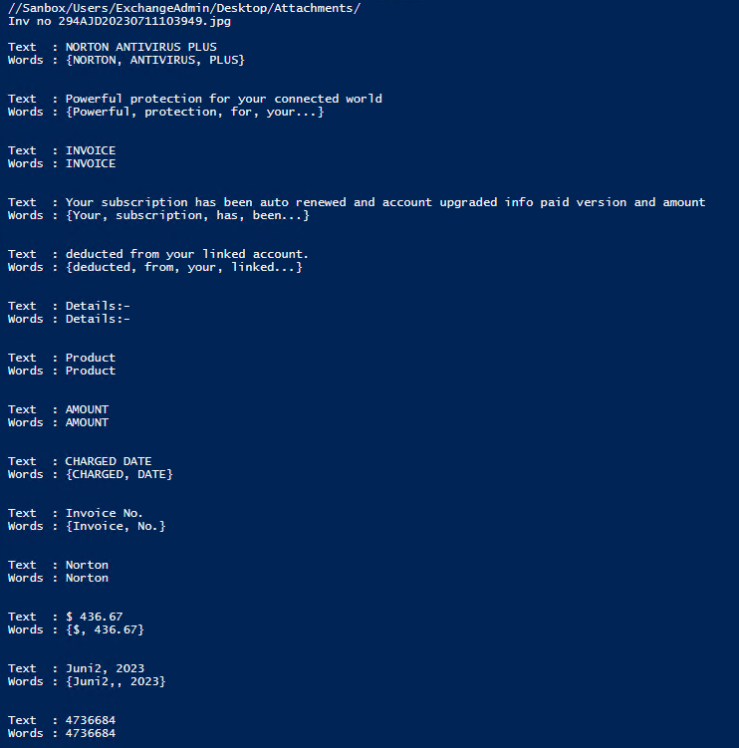

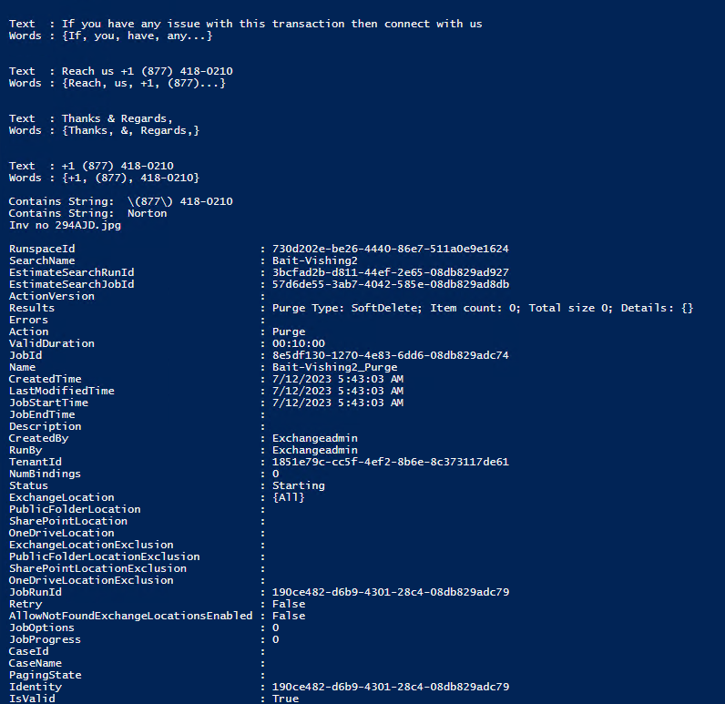

**Simulated Test-9:** Fake Invoice Image-9

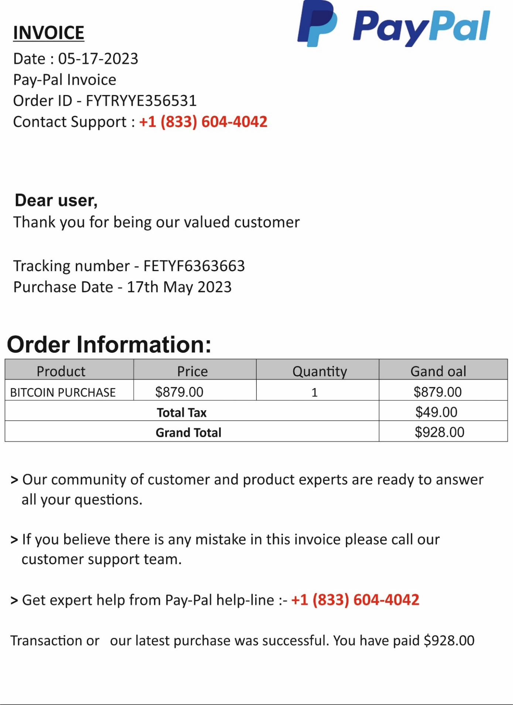

**Simulated Test-9 results:** The script extracted text from Fake Invoice Image-9 and removed the phishing email.

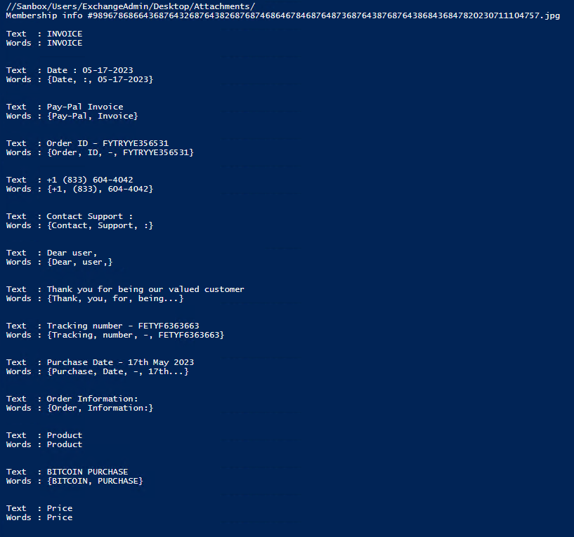

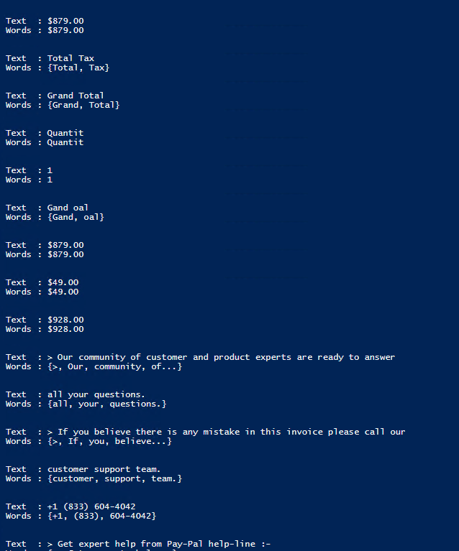

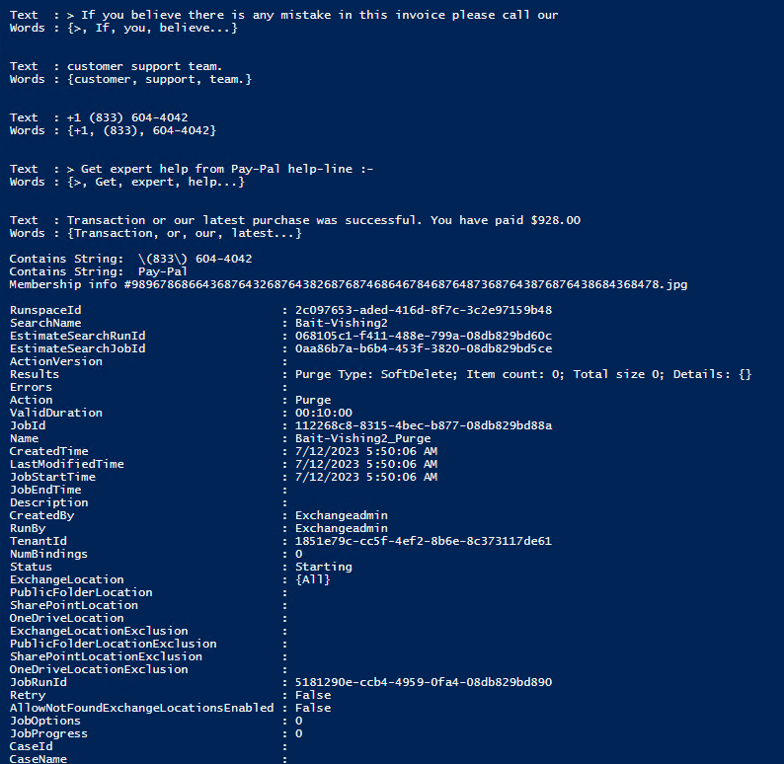

**Simulated Test-10:** Fake Invoice Image-10

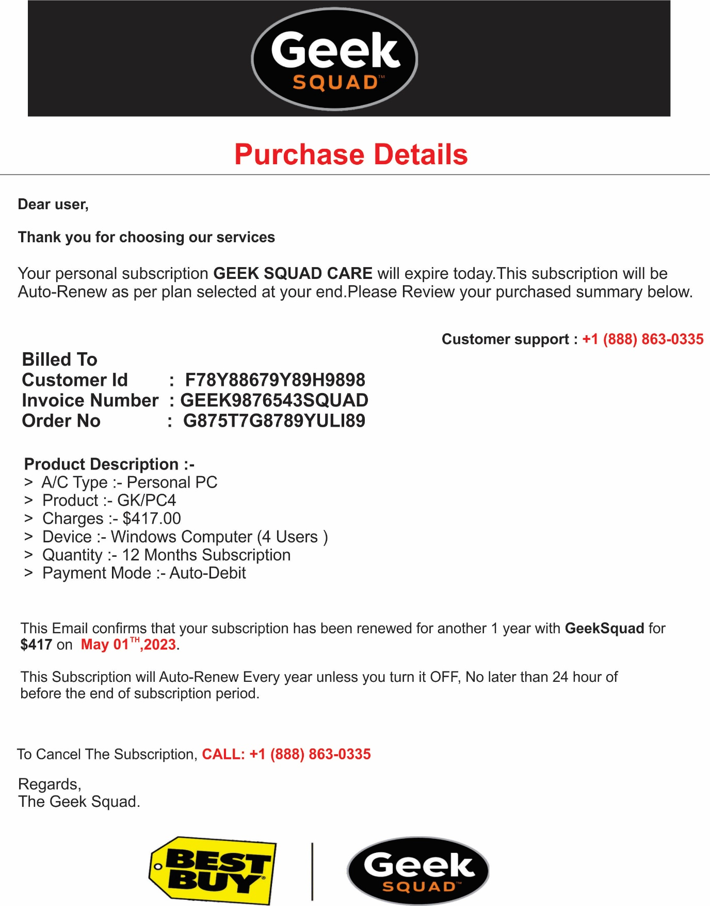

**Simulated Test-10 results:** The script extracted text from Fake Invoice Image-10 and removed the phishing email.

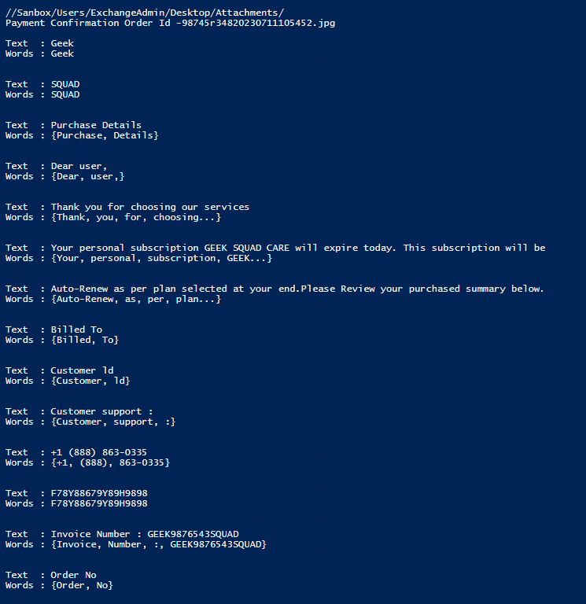

Payment-Confirmation-2

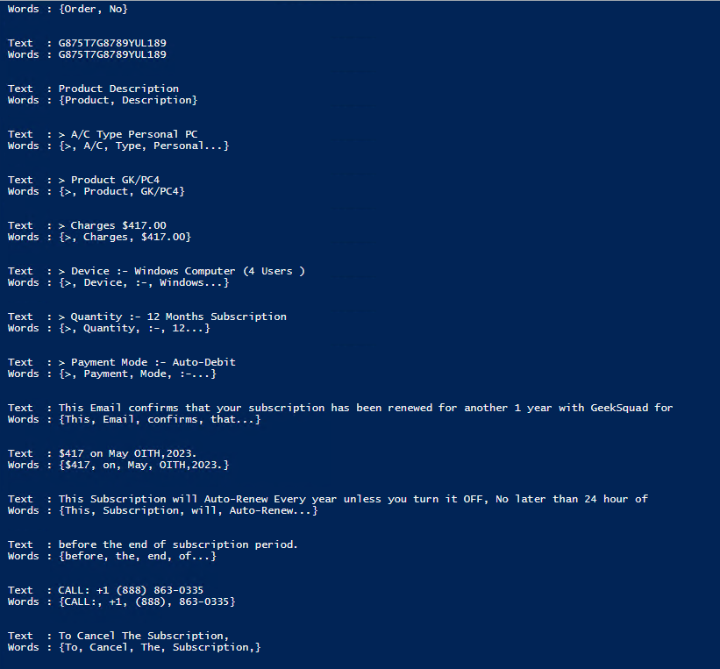

Payment-Confirmation-3

